# Project Report On



**HOSTING A DYNAMIC WEBSITE USING AWS EC2 & VPC**

### Submitted by

### Yerragoti Chiranjeevi - R171221

**Under the guidance of**

**S Shabana**

**Assistant Professor**

### Department of Computer Science and Engineering

**Rajiv Gandhi University of Knowledge and Technologies(RGUKT), R.K.Valley, Kadapa, Andra Pradesh.**

# Declaration

We, hereby declares that this report entitled “**Hosting a Dynamic**

**website using the AWS EC2 & VPC.**” submitted by us under the guidance

and supervision of **S. Shabana**  is a bonafide work. We also declare that it

has not been Submitted previously in part or in full to this university or other

university or Institution for the award of any degree or diploma.

We will be solely responsible if any kind of plagiarism is found.

Place:- RK Valley Yerragoti Chiranjeevi –R171221



**Rajiv Gandhi University of Knowledge Technologies RK Valley**, Kadapa (Dist), Andhra Pradesh, 516330

**CERTIFICATE**

This is to certify that the project work titled “**HOSTING A DYNAMIC WEBSITE USING AWS EC2 & VPC**” is a bonafied project work submitted by Chiranjeevi Yerragoti in the department of COMPUTER SCIENCE AND ENGINEERING in partial fulfillment of requirements for the award of degree of Bachelor of Technology in Computer science and engineering for the year 2022-2023 carried out the work under the supervision

GUIDE HEAD OF THE DEPARTMENT

S SHABANA N SATYANANDARAM

# ACKNOWLEDGEMENT

The satisfaction that accompanies the successful completion of any task would be incomplete without the mention of the people who made it possible and whose constant guidance and encouragement crown all the efforts success.

I am extremely grateful to our respected Director, Prof. K. SANDHYA RANI for fostering an excellent academic climate in our institution.

I also express my sincere gratitude to our respected Head of the Department Mr. N SATYANANDARAM for his encouragement, overall guidance in viewing this project a good asset and effort in bringing out this project.

I would like to convey thanks to our guide at college Ms. S SHABANA for her guidance, encouragement, co-operation and kindness during the entire duration of the course and academics.

My sincere thanks to all the members who helped me directly and indirectly in the completion of project work. I express my profound gratitude to all our friends and family members for their encouragement.

# INDEX

|  |  |  |
| --- | --- | --- |
| **S.NO** | **INDEX** | **PAGE NUMBER** |
| 1 | Abstract | 5 |
| 2 | Introduction | 6-7 |
| 3 | purpose | 8 |
| 4 | Scope | 8 |
| 5 | Requirement Specification | 9-10 |
| 6 | Analysis | 11 |
| 7 | Creating AWS Account | 12 |
| 8 | Login | 13 |
| 9 | Creating a VPC Virtual Private Cloud. | 14 |
| 10 | Creating Subnets | 15-16 |
| 11 | Route Table Creation | 17-19 |
| 12 | Subnet Association | 19-21 |
| 13 | Creating EC2 and Creating key pair & Configuring the Storage. | 21- 27 |
| 14 | Downloading remote Server | 27-29 |
| 15 | Hosting website inside the remote server. | 30-31 |
| 16 | Hosting website outside the remote server. | 32 |
| 17 | Implementation and Testing | 33 |
| 18 | Conclusion | 34 |
| 19 | Reference | 34 |

**Abstract**

This project is about Hosting a dynamic website using AWS EC2 and VPC is a reliable and scalable solution for businesses that need to serve content to a global audience. EC2 allows for the creation of virtual machines that can be customized to meet the specific needs of the website. VPC provides a secure and isolated environment for the website to operate in, ensuring that sensitive data and applications are protected. By utilizing the flexibility and power of these two services, businesses can create a dynamic website that is highly available, scalable, and secure. This abstract will explore the benefits and best practices of hosting a dynamic website using AWS EC2 and VPC, including how to configure and manage the infrastructure, how to optimize for performance and cost, and how to ensure high availability and disaster recovery. For that we create an Free tier account in AWS. AWS has developed a great idea to publicly provide an easy and simple solution for their users to host content using the AWS EC2 & VPC. I host a website related to car rental management system into Amazon EC2 & VPC and it gives an URL to access the webpage. EC2 helps us to Access the remote server in that we need to host the website. I used XAMPP server in the EC2 instance. After hosting that ec2 will have a IP address with the IP address we can access the web page anywhere.

Key words: AWS EC2 & VPC, Dynamic website, data centers, cloud servers, server-side, web-applications, Xampp Server.

# Introduction

#### Dynamic Websit*e*

A dynamic website is a website that displays different content and interacts with users based on their behavior, preferences, and inputs. Unlike static websites, which display the same content to all visitors, dynamic websites use programming languages such as PHP, JavaScript, and others to generate content on the fly and provide a personalized user experience.

Dynamic websites can include features such as user logins, personalized content, interactive forms, real-time updates, and more. They often require a back-end database and server-side scripting to generate content and manage user interactions. The use of dynamic content allows websites to be more engaging, responsive, and tailored to individual users' needs, making them an ideal solution for businesses looking to provide a high-quality online experience.

**AWS EC2 :**

Amazon Elastic Compute Cloud (EC2) is a web service that provides resizable compute capacity in the cloud. It is one of the core components of Amazon Web Services (AWS) and allows users to launch and manage virtual machines (instances) on demand.

EC2 instances can be configured with a variety of operating systems, applications, and software, making it a flexible solution for a wide range of use cases. Users can also choose from a variety of instance types based on their specific needs, such as compute-optimized instances for high-performance computing, memory-optimized instances for in-memory databases, or storage-optimized instances for big data processing.

One of the key advantages of EC2 is its scalability. Users can quickly launch additional instances or remove them as needed to handle fluctuating workloads and traffic. EC2 also provides high availability by automatically distributing instances across multiple availability zones, ensuring that applications remain available in the event of hardware failures or other disruptions.

EC2 instances can be managed through a web-based management console, command-line tools, or APIs, making it easy for users to deploy and manage their applications in the cloud. With pay-as-you-go pricing and no upfront costs, EC2 is a cost-effective solution for businesses of all sizes.

**AWS VPC :**

Amazon Virtual Private Cloud (VPC) is a web service that allows users to create and manage their own private virtual network within the AWS cloud. VPC provides a secure and isolated environment that users can configure with their own IP address range, subnets, routing tables, and security settings.

With VPC, users can launch EC2 instances and other resources in a private and controlled environment. They can also configure a variety of network connectivity options, including private connectivity between VPCs, direct connections to on-premises data centers, and VPN connections to remote networks.

VPC also provides a range of security features to protect resources within the virtual network, including network access control lists (ACLs), security groups, and encrypted communication options. Users can also configure VPC flow logs to capture network traffic for analysis and monitoring.

One of the key benefits of VPC is its flexibility. Users can create multiple VPCs within their AWS account and configure them to meet their specific needs. VPC also integrates with other AWS services, such as EC2, RDS, and S3, making it easy to launch and manage resources within a private and secure network.

VPC is a powerful tool for businesses that require a secure and isolated environment within the AWS cloud. With its flexibility, scalability, and security features, VPC provides users with complete control over their network and resources, allowing them to build and deploy applications with confidence.

# Purpose

The purpose of hosting a dynamic website using AWS EC2 and VPC is to provide a highly scalable, secure, and customizable solution for businesses that need to serve content to a global audience. By utilizing the power and flexibility of EC2 and VPC, businesses can create a dynamic website that can handle fluctuations in traffic demand, protect sensitive data and applications from external threats, and customize the infrastructure to meet the specific needs of the website. The purpose is to provide a reliable and efficient solution that enables businesses to focus on their core operations, while AWS handles the website infrastructure. Additionally, hosting a dynamic website using AWS EC2 and VPC allows businesses to take advantage of AWS's expertise in managing and optimizing the infrastructure, leading to improved website performance, availability, and cost-effectiveness.

# Scope

The scope of hosting a dynamic website using AWS EC2 and VPC encompasses the entire process of setting up, configuring, and managing the infrastructure required to serve dynamic content to users. This includes creating EC2 instances, configuring security groups and VPCs, optimizing for performance and cost, and implementing disaster recovery solutions. Additionally, the scope includes monitoring and managing the website's infrastructure to ensure high availability, scalability, and security.

The scope also includes the customization of the infrastructure to meet the specific needs of the website, such as selecting an appropriate operating system, configuring software, and implementing caching solutions. Best practices for managing the infrastructure, optimizing for cost and performance, and disaster recovery planning are also included in the scope.

### Advantages:

### Scalability: AWS EC2 allows businesses to easily scale up or down their website infrastructure as needed, ensuring that it can handle traffic spikes and fluctuations.

### Security: VPC provides a secure and isolated environment for the website to operate in, helping to protect sensitive data and applications from external threats.

### Customization: EC2 allows for the creation of virtual machines that can be customized to meet the specific needs of the website, including configuring operating systems, software, and security settings

### High Availability: EC2 instances can be distributed across multiple availability zones.

### Disadvantages:

1. **Technical complexity**: Setting up and managing the infrastructure requires technical expertise, which may be a challenge for some businesses.
2. **Potential for cost overruns**: While AWS offers cost-effective solutions, businesses must still carefully manage their usage to avoid unexpected costs.
3. **Reliance on third-party services**: Hosting a website on AWS means relying on a third-party service, which can introduce risk and may require additional security and compliance measures.
4. **Performance issues**: While AWS offers high-performance infrastructure, businesses must ensure that their website is properly optimized and configured to take advantage of this infrastructure.
5. **Network issues**: Connectivity issues can occur due to AWS infrastructure, which may require troubleshooting and additional resources to address.

# Requirement Specification

### Hardware Configuration:

**Client Side:**

|  |  |
| --- | --- |
| **Ram** | 512 MB |
| **Hard disk** | 10 GB |
| **Processor** | 1.0 GHz |

### Software Requirement:

|  |  |
| --- | --- |
| **Front end** | HTML,CSS ,Java Script,PHP. |
| **Web Browser** | Firefox , Google Chrome or any compatible browser. |
| **Operating System** | Ubuntu,Windows or any equivalent OS. |
| **Tool** | AWS EC2 & VPC. |
| **Technology** | Cloud Computing. |

**HTML:-**

HTML is a *markup language t*hat defines the structure of your

content. HTML consists of a series of elements, which you use to enclose, or wrap, different parts of the content to make it appear a certain way, or act a certain way. The enclosing tags can make a word or image hyperlink to somewhere else, can italicize words, can make the font bigger or smaller, and so on.

**CSS:-**

Cascading Style Sheets is a stylesheet language used to describe

the presentation of a document written in HTML or XML . It describes how elements should be rendered on screen, on paper, in speech, or on other media. It helps Web developers create a uniform look across several pages of a Web site. Instead of defining the style of each table and each block of text within a page's HTML, commonly used styles need to be defined only once in a CSS document. It can be used to define the cell padding of table cells, the style, thickness, and color of a table's border, and the padding around images or other objects.This is why most Web pages today incorporate cascading style sheets.

**Java Script:-**

JavaScript is a scripting or programming language that allows you

to implement complex features on web pages every time a web page does more than just sit there and display static information for you to look at displaying timely content updates, interactive maps, animated 2D/3D graphics, scrolling video jukeboxes, etc., It is the third layer of the layer cake of standard web technologies, two of which HTML and CSS. A very common use of JavaScript is to dynamically modify HTML and CSS to update a user interface, via the Document Object Model API . Look at that the code in your web documents is generally loaded and executed in the order it appears on the page.

**HTTP:-**

HTTP is a protocol for fetching resources such as HTML

documents. It is the foundation of any data exchange on the Web and it is a client-server protocol, which means requests are initiated by the recipient, usually the Web browser. A complete document is reconstructed from the different sub-documents fetched, for instance, text, layout description, images, videos, scripts, and more. Clients and servers communicate by exchanging individual message.

**PHP:-**

PHP (Hypertext Preprocessor) is an open-source, server-side scripting language used for web development. It was originally designed for creating dynamic web pages and is used to build websites, web applications, and content management systems. PHP code is executed on the server before the web page is sent to the user's browser, which allows for the creation of dynamic content that can be customized based on user input, database queries, or other factors.

# Analysis

### Analysis:

Hosting a dynamic website using AWS EC2 and VPC offers numerous advantages for businesses. The scalability of AWS infrastructure allows for easy scaling up or down of the website infrastructure as needed, ensuring that it can handle traffic spikes and fluctuations. The security provided by VPC helps protect sensitive data and applications from external threats, making it an ideal solution for businesses that handle sensitive information.

The customization offered by EC2 allows businesses to create virtual machines that can be customized to meet the specific needs of the website, including configuring operating systems, software, and security settings. The high availability of EC2 instances distributed across multiple availability zones ensures that the website is highly available and can handle failures without downtime.  
 Another advantage of hosting a dynamic website using AWS EC2 and VPC is the cost-effectiveness of AWS's pay-as-you-go pricing models and the ability to scale infrastructure up or down as needed, helping to reduce costs for businesses.

However, there are also some potential drawbacks to consider. Technical complexity is one of the main concerns, as setting up and managing the infrastructure requires technical expertise, which may be a challenge for some businesses. Additionally, businesses must carefully manage their usage to avoid unexpected costs, as AWS offers cost-effective solutions, but still requires proper management to avoid cost overruns.

Reliance on third-party services is also a consideration, as hosting a website on AWS means relying on a third-party service, which can introduce risk and may require additional security and compliance measures. Performance issues can also arise if the website is not properly optimized and configured to take advantage of the high-performance infrastructure offered by AWS. Finally, connectivity issues can occur due to AWS infrastructure, which may require troubleshooting and additional.

#### Creating a AWS Account

1. Go to the AWS homepage at aws.amazon.com and click the "Create an AWS Account" button.
2. Enter your email address and a strong password, and then click "Continue".
3. Enter your personal information, including your name, address, and phone number, and then click "Create Account and Continue".
4. Choose the account type and support plan that best fits your needs, and then click "Continue".
5. Enter your payment information, such as a credit card number or bank account information, and then click "Verify and Add".
6. Review and accept the AWS Customer Agreement and the AWS Service Terms, and then click "Create Account and Continue".
7. Verify your identity by entering a verification code sent to your phone or email, and then click "Verify Code".
8. Once your account is created, you can log in to the AWS Management Console to access your services and resources.

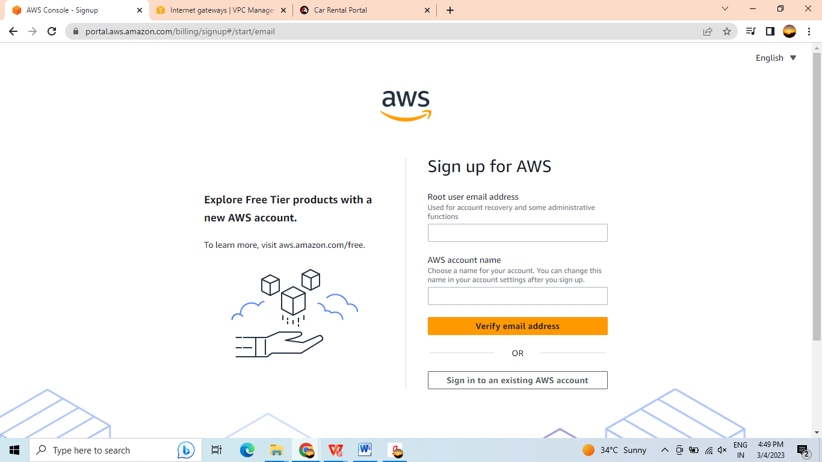

Login:- Here we will have two types of logins

1. Login with root user.

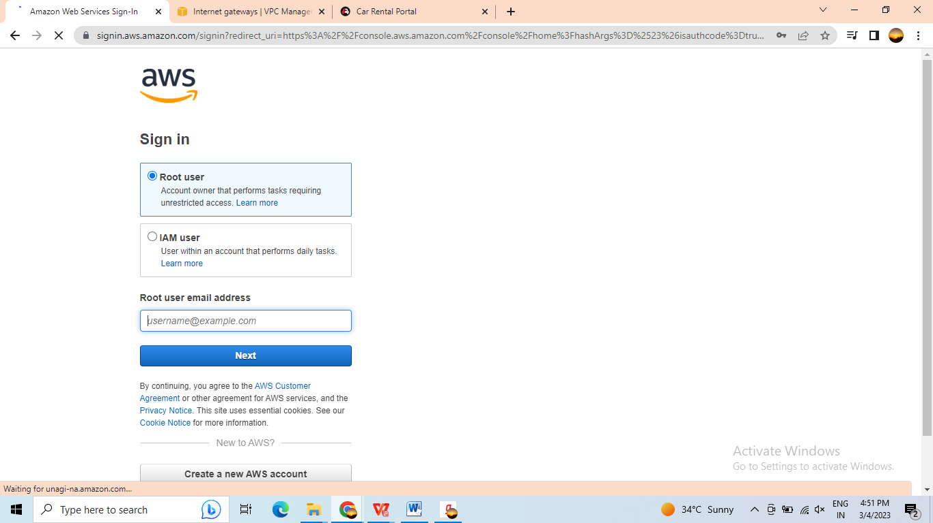

1. login with IAM user.

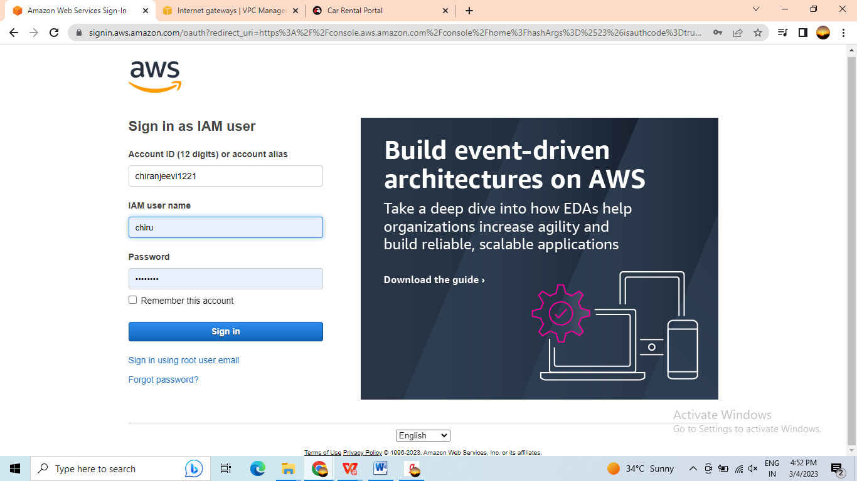

#### Creating Virtual Private Cloud(VPC) in AWS

1. Log in to the AWS Management Console and navigate to the VPC dashboard.
2. Click "Create VPC" to start the VPC creation wizard.

3. Enter a name and IPv4 CIDR block for your VPC. The CIDR block specifies the IP address

range for your VPC.

4.Choose whether to enable IPv6 support for your VPC.

5.Choose whether to enable DNS hostnames and DNS resolution for your VPC.

6.Click "Create" to create your VPC.

7. Once your VPC is created, you can create subnets, route tables, and security groups to configure your network.

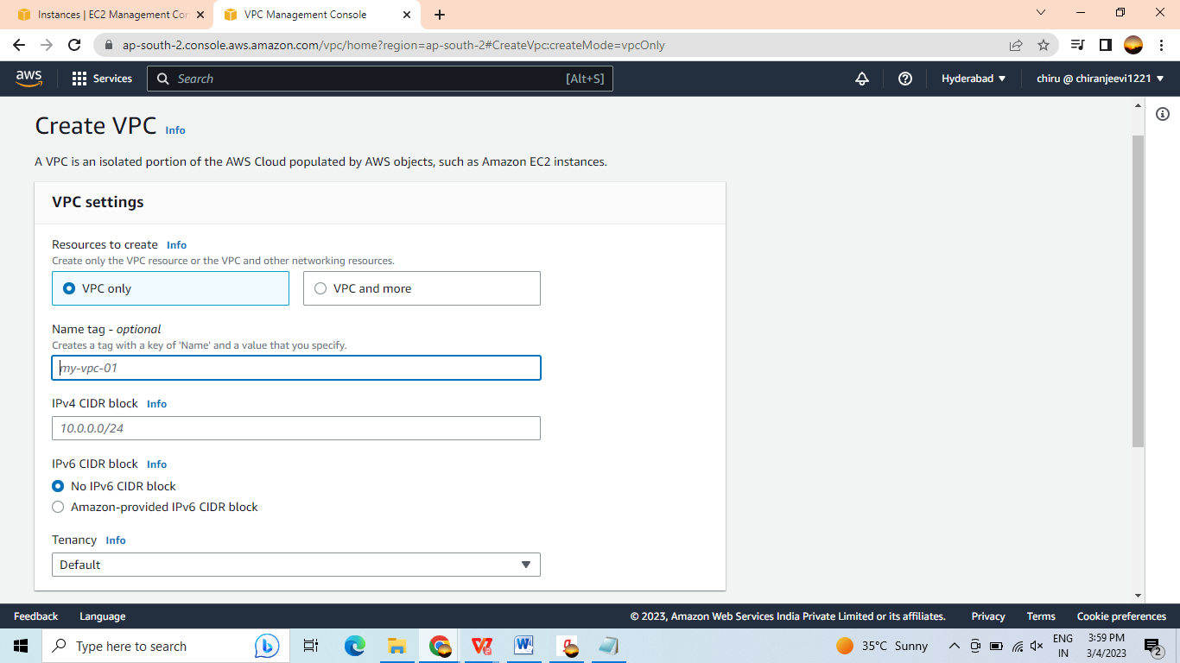

This is my VPC I had created this Virtual Private Cloud.

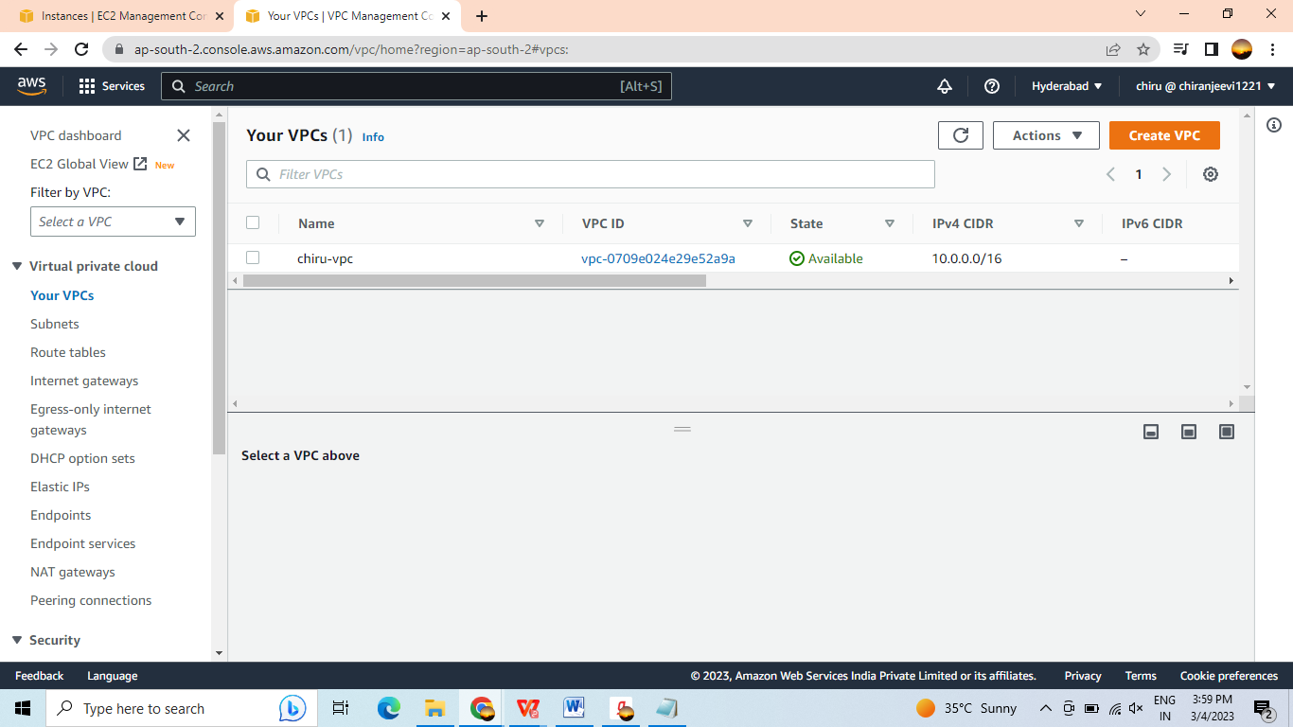

##### Creating Subnets For this VPC

1. In the left navigation pane, click on "Subnets".
2. Click the "Create subnet" button.
3. In the "Create subnet" dialog, enter the following information:
4. Name tag: A name to identify your subnet
5. VPC: The VPC where you want to create the subnet
6. Availability Zone: The Availability Zone where you want to create the subnet
7. IPv4 CIDR block: The IP address range for the subnet, in CIDR notation
8. Note: The IP address range for the subnet must be a subset of the IP address range for the VPC.
9. Click the "Create" button to create the subnet.
10. Repeat steps 3 to 5 for each additional subnet you want to create.
11. Once you have created your subnets, you can associate them with your EC2 instances, RDS instances, and other resources in your VPC. To do this, navigate to the "Instances" or "DB instances" section of the AWS Management Console, select the resource you want to modify, and click "Actions" > "Networking" > "Change subnet association".

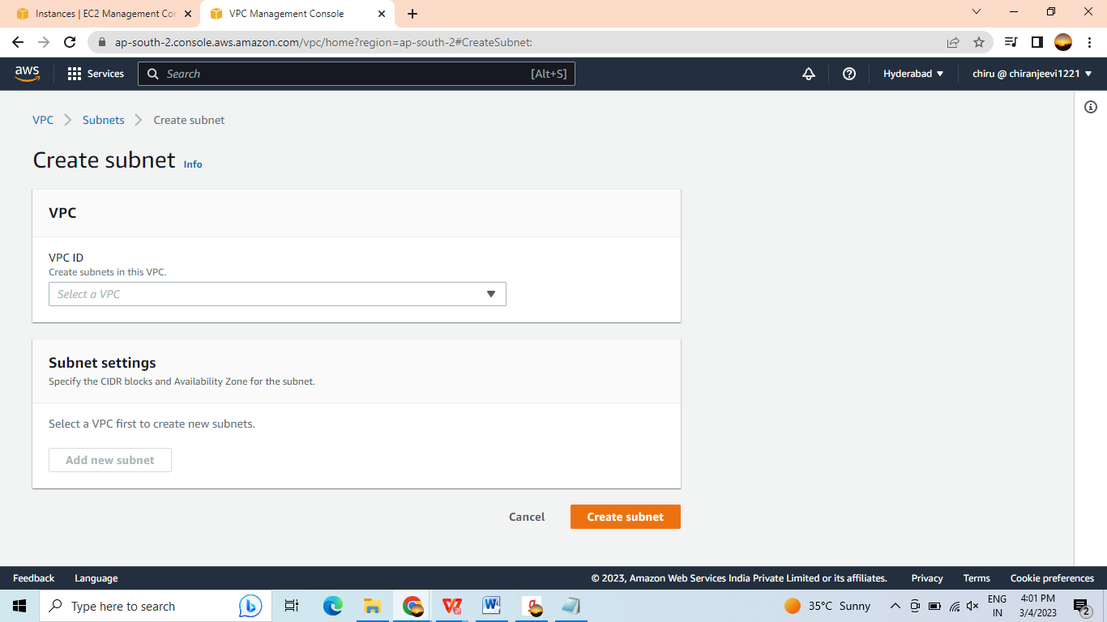

By using above method I had created some subnets.

I had created 2 public subnets and 2 private subnets for two availability zones. In one region I had created two multiple zones. These two public subnets are created in the two availability zones.

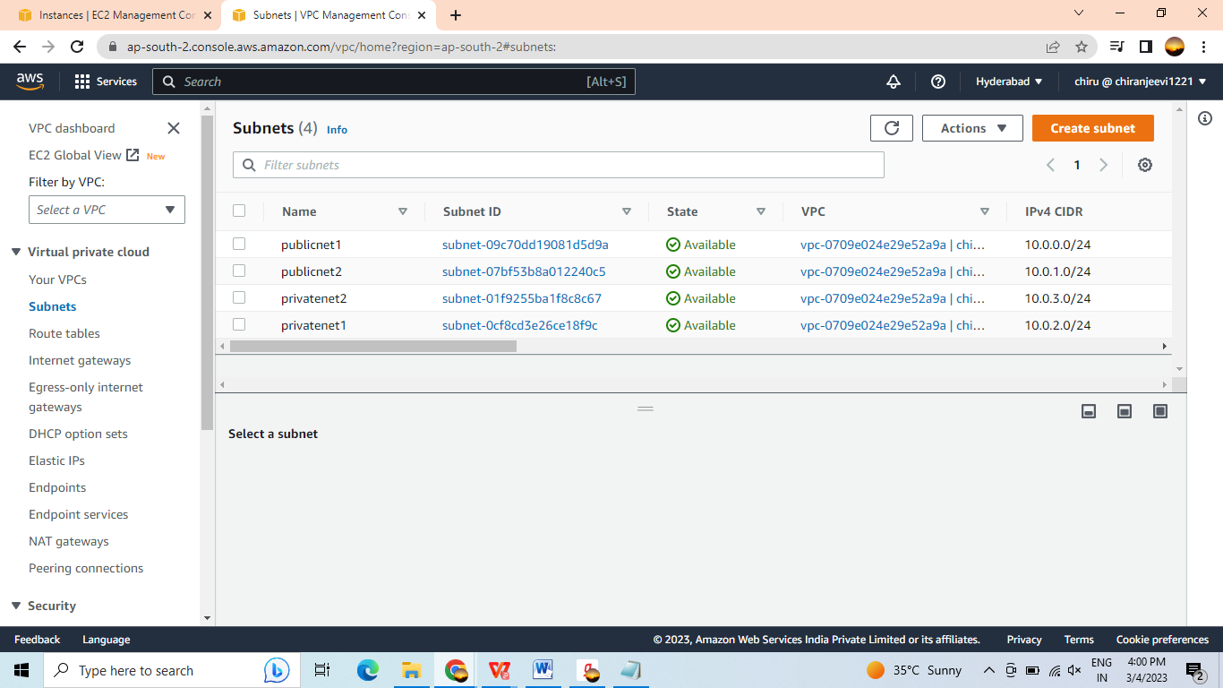

#### Route Table Creation.

1. Open the AWS Management Console and navigate to the VPC dashboard.
2. In the left navigation pane, click on "Route Tables".
3. Click the "Create route table" button.
4. In the "Create route table" dialog, enter the following information:
5. Name tag: A name to identify your route table
6. VPC: The VPC where you want to create the route table
7. Click the "Create" button to create the route table.
8. Once the route table is created, you can add routes to it to define the paths for network traffic in your VPC. To add a route, follow these steps:
9. Select the route table you just created in the "Route Tables" section of the AWS Management Console.
10. Click the "Routes" tab.
11. Click the "Edit routes" button.
12. Click the "Add route" button.
13. In the "Add route" dialog, enter the destination CIDR block for the route and the target for the

traffic (e.g., an Internet Gateway, a NAT Gateway, or a VPC peering connection).

1. Click the "Save" button to add the route.

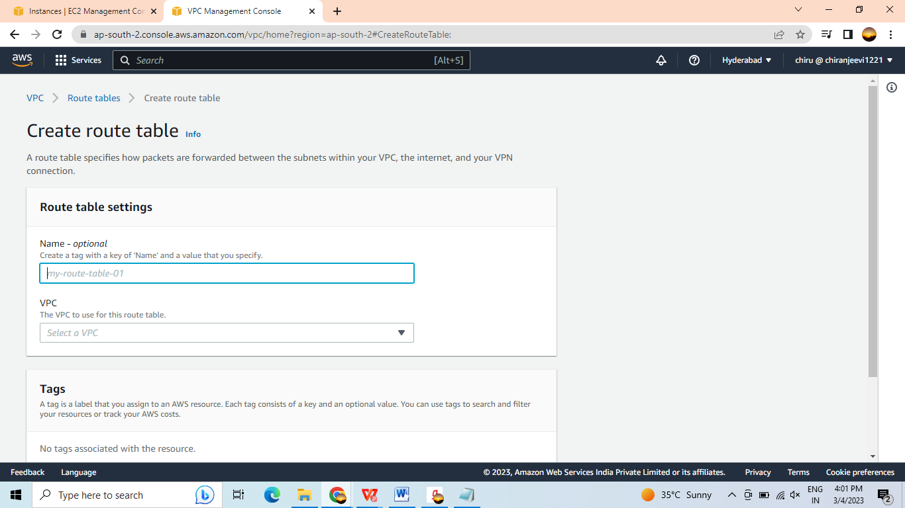

By using the above steps I had created the route table.

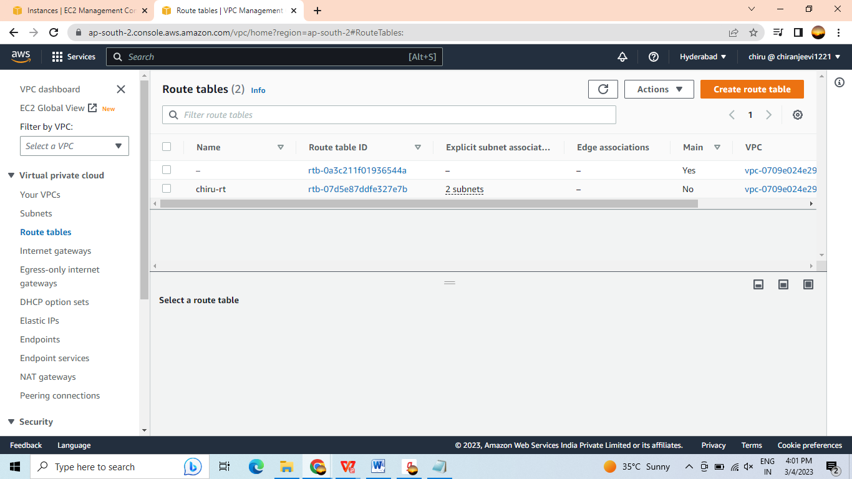

Steps to create Subnet Associations.

1. Once you have added the routes you need, you can associate the route table with your subnets. To do this, follow these steps:
2. Select the route table you just created in the "Route Tables" section of the AWS Management Console.
3. Click the "Subnet associations" tab.
4. Click the "Edit subnet associations" button.
5. Select the subnets you want to associate with the route table.
6. Click the "Save" button to associate the subnets with the route table

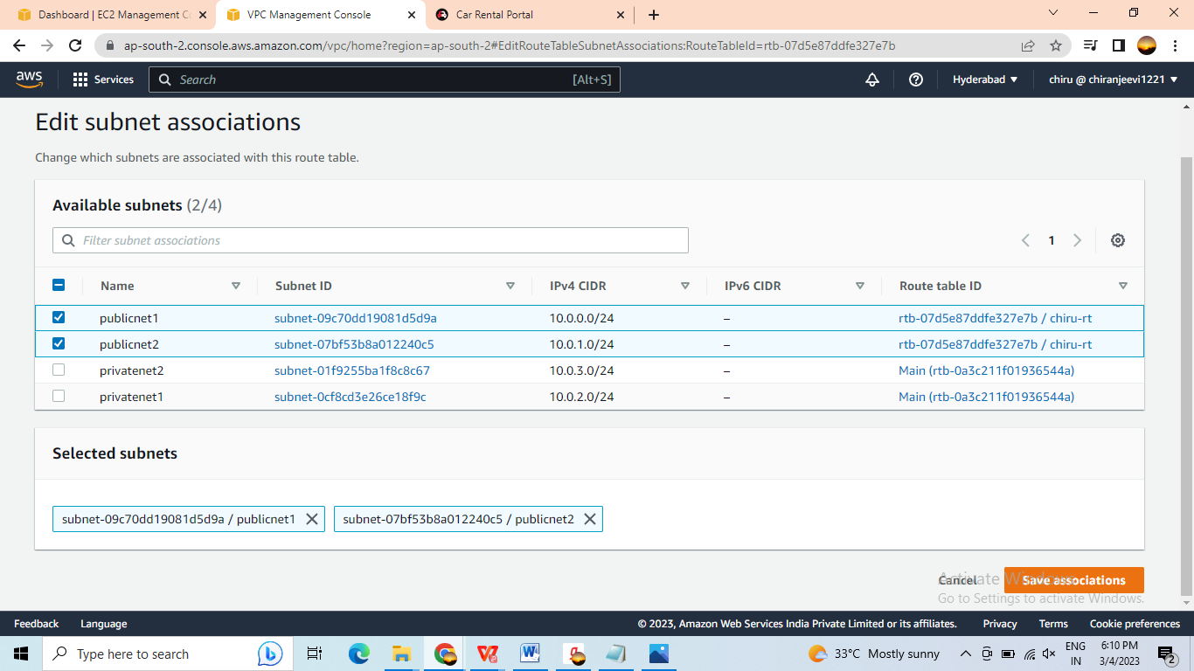

**By using the above steps I had created the subnet Association**

**I had created with two public subnets. Because we don’t need to access the private subnets with the help of any address. Private subnets always used in the management console. So that why I used two public subnets to accosiate with the router.**

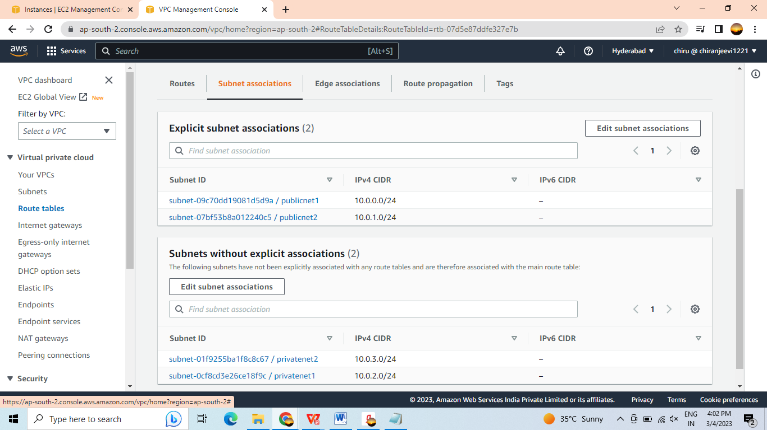

#### Creation of EC2 Instance in AWS.

1. Log in to the AWS Management Console and navigate to the EC2 dashboard.
2. Click "Launch Instance" to start the EC2 instance creation wizard.
3. Choose an Amazon Machine Image (AMI) for your instance. An AMI is a pre-configured virtual machine image that includes an operating system and any additional software or configuration that you need.
4. Choose an instance type for your instance. Instance types define the hardware resources (such as CPU, memory, and storage) available to your instance.
5. Configure the details of your instance, including the number of instances to launch, the VPC and subnet to launch the instance in, and any additional storage or network interfaces.
6. Configure the security settings for your instance, including the security group and any additional firewall rules.
7. Review the details of your instance and click "Launch" to launch your instance.
8. Once your instance is launched, you can connect to it using an SSH client or remote desktop client, depending on the operating system and configuration of your instance.
9. To access your instance, navigate to the "Instances" tab in the EC2 dashboard and locate your instance. From here, you can view the instance details, manage the instance, and connect to the instance using the provided SSH or remote desktop connection information.

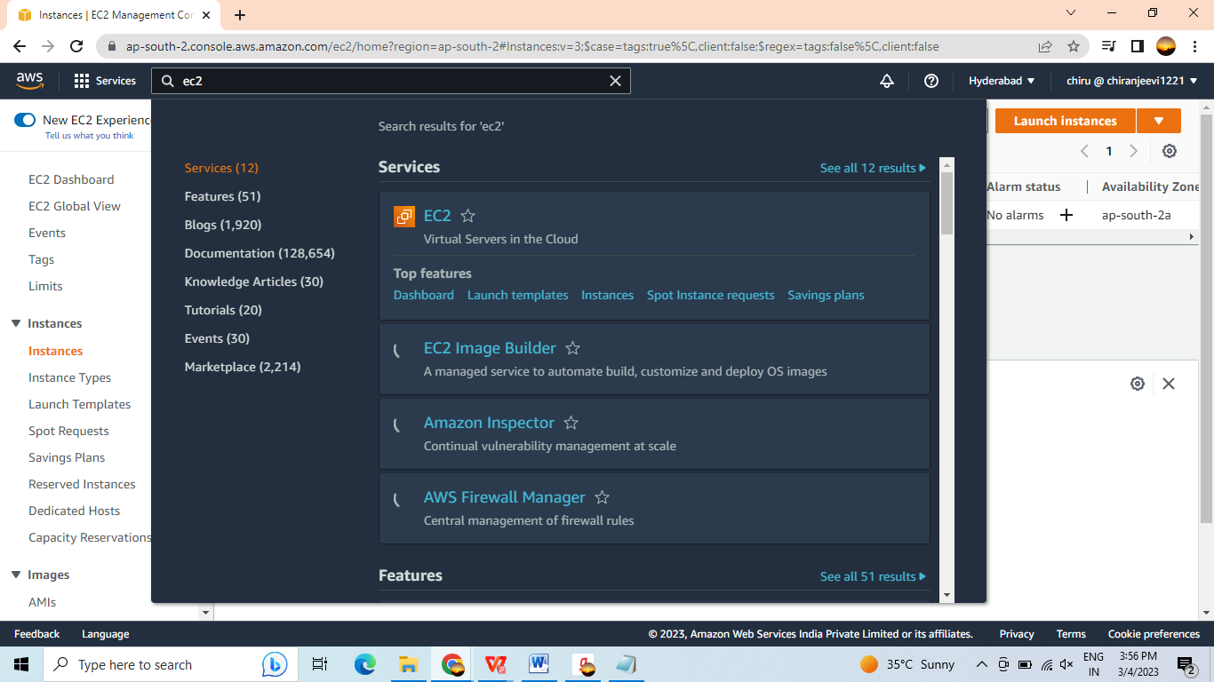

In the navigation bar we need to search the EC2. After that the ec2 console will open for us.

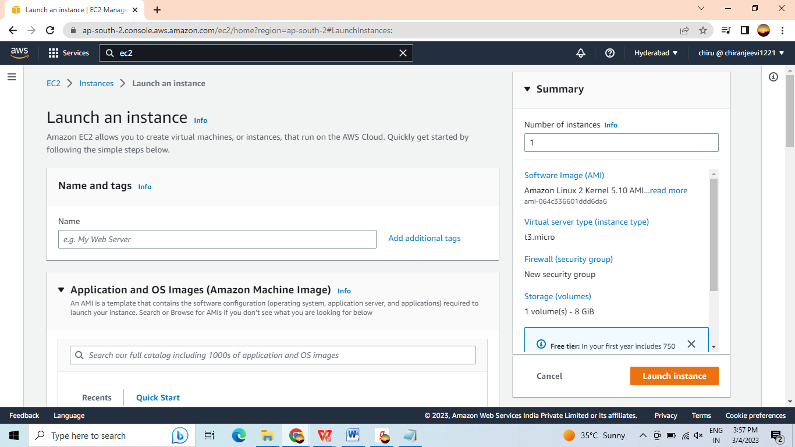

Now we need to details here.

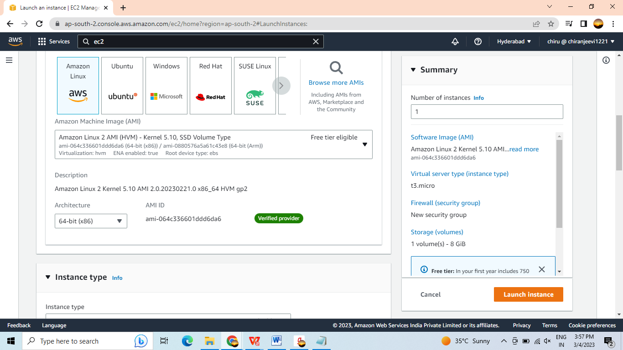

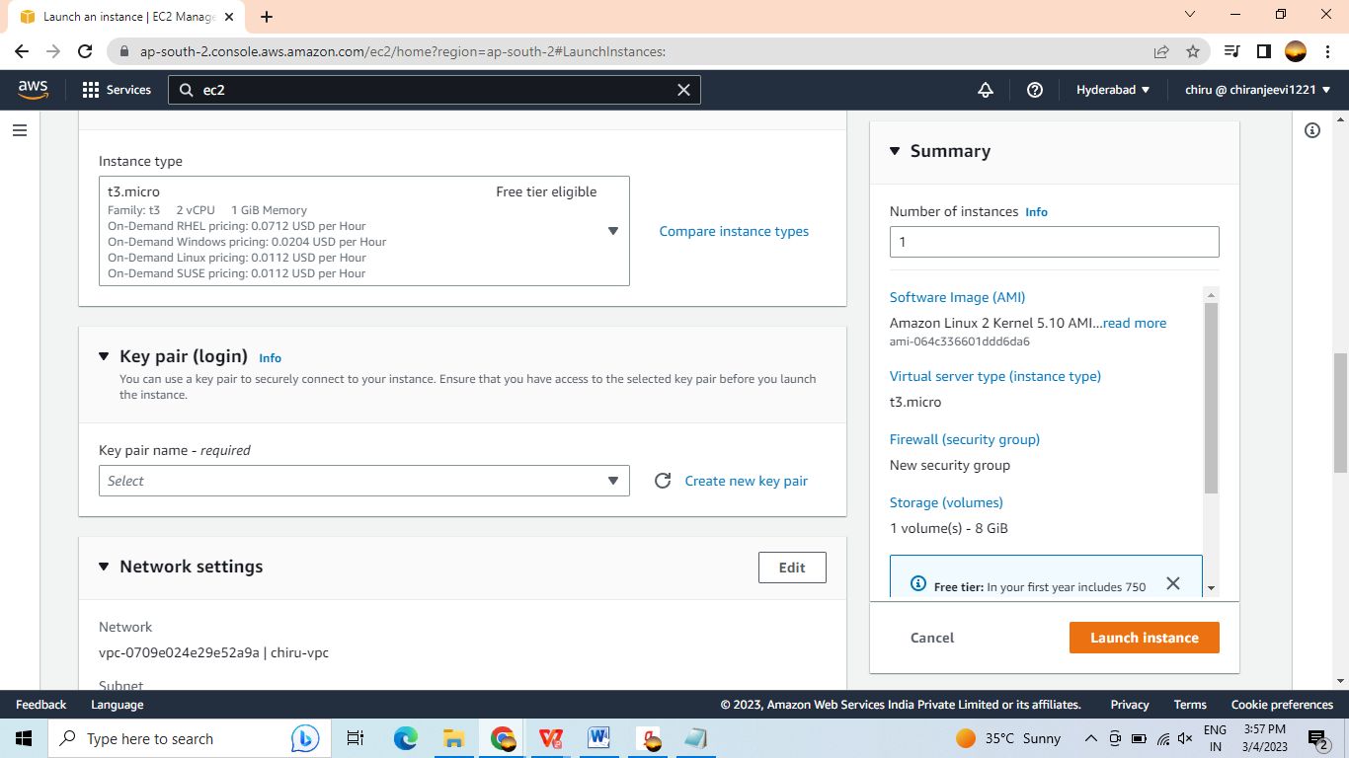

**Here we need to generate the key pair.**

**Generation new key pair.**

1. Open the AWS Management Console and navigate to the EC2 dashboard.
2. In the left navigation pane, click on "Key Pairs".
3. Click the "Create Key Pair" button.
4. In the "Create Key Pair" dialog, enter the following information:
5. Name: A name for your key pair
6. File format: The format in which to save your private key (e.g., .pem, .ppk)
7. Note: You will need to download and save the private key file, as it will not be accessible again once you leave the page.
8. Click the "Create" button to generate the key pair.
9. Once the key pair is generated, you can use it to access your EC2 instances. To do this, follow these steps:
10. Launch a new EC2 instance, or select an existing instance.
11. In the "Configure Instance Details" page, expand the "Advanced Details" section.
12. In the "User Data" field, enter any desired commands to run when the instance launches.
13. In the "Network and Security" section, select your key pair from the "Key Pair" dropdown.
14. Click the "Review and Launch" button to launch the instance with your key pair.

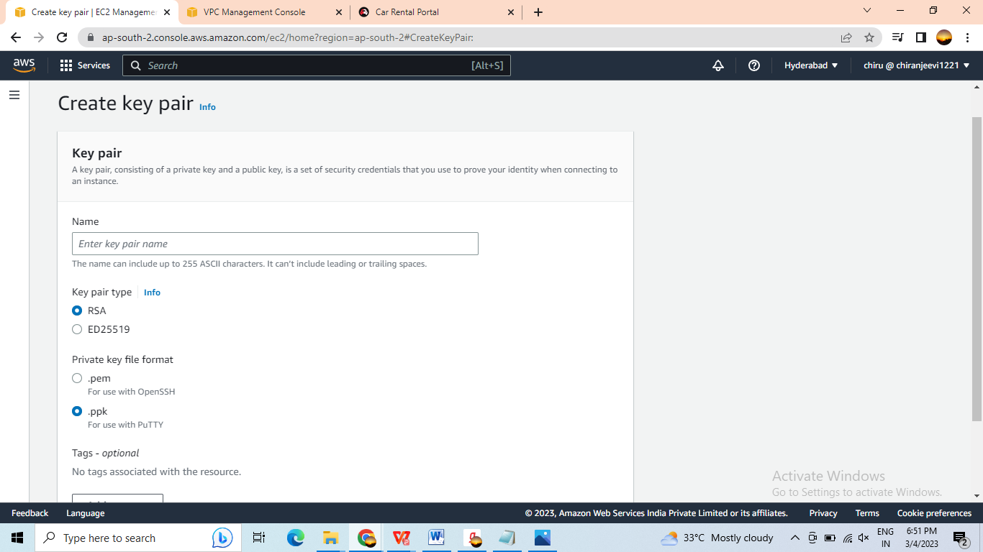

After that need to go with network configuration.

In network we need to add the VPC created before creating the EC2.

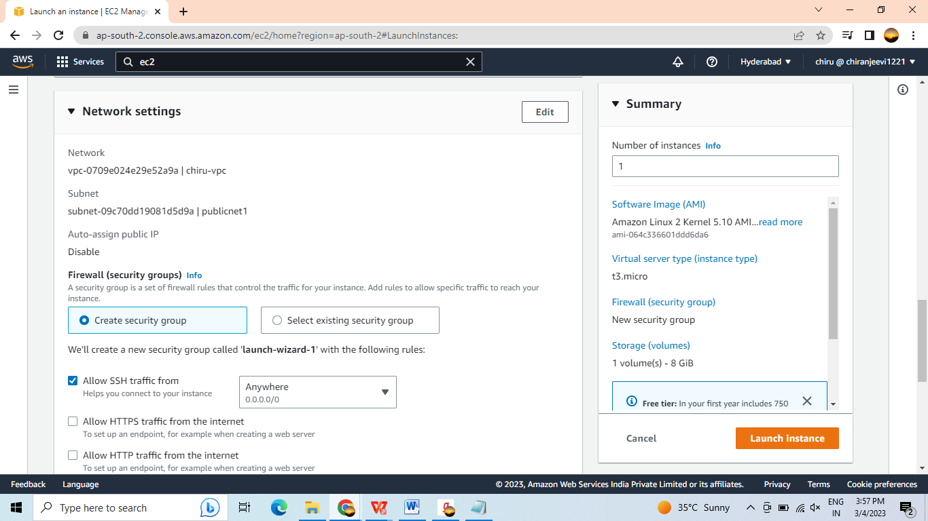

**After that need to configure the storage.**

**To configure storage in EC2, you can create EBS volumes, attach them to EC2 instances, and format them with the desired file system. You can also create Instance Store volumes when launching an instance, and use them for temporary data storage. EFS and S3 can be accessed from EC2 instances over the network using standard protocols (e.g., NFS, HTTP/S).**

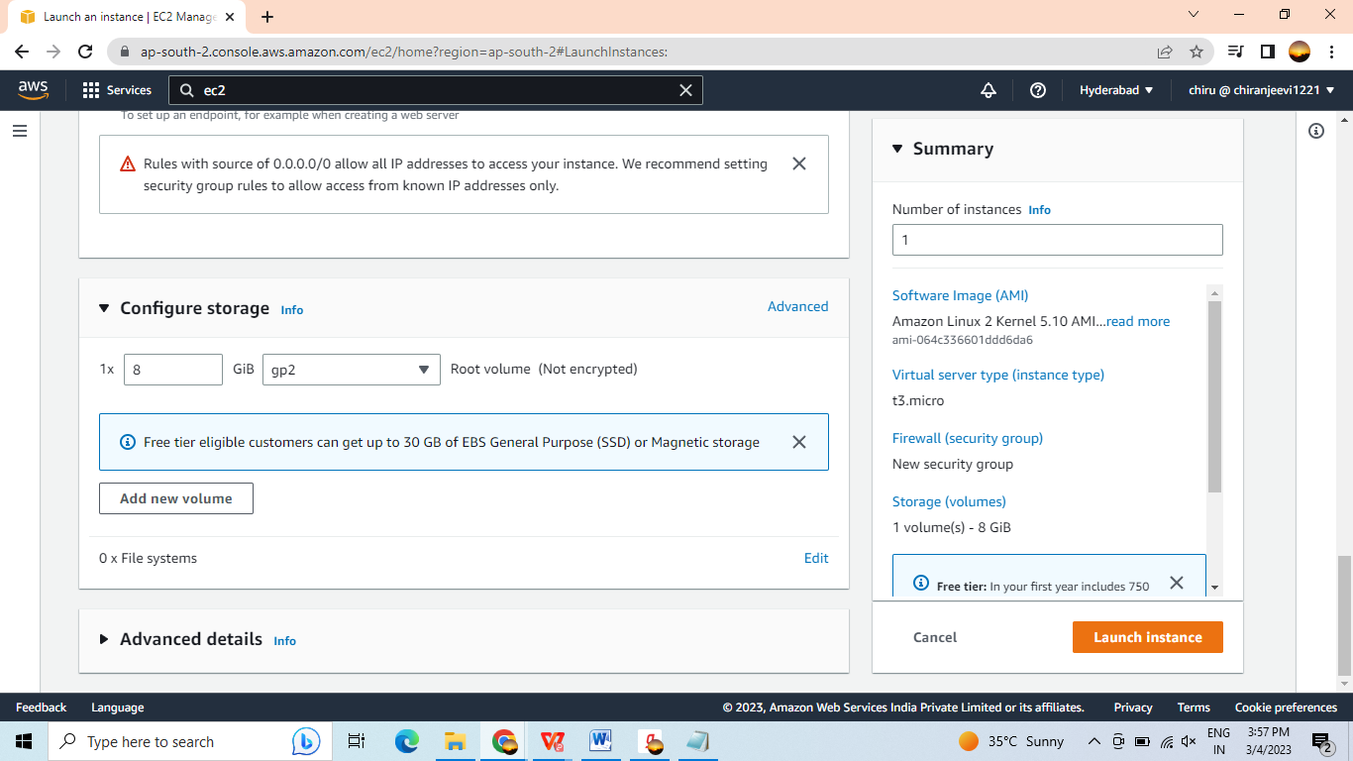

Review the details of your instance and click "Launch" to launch your instance.

Now we need to download a remote server based app.

After creating the EC2 in the connect option will showed Click the “Connect” option to download the remote server application. I used Windows operating system to run my files.

After clicking the connect button it will show you session manger and RDP client need to click on the RDP client to download the application.

There we need to generate the password using the key we created in key pairing. After generating the password need to download the application.

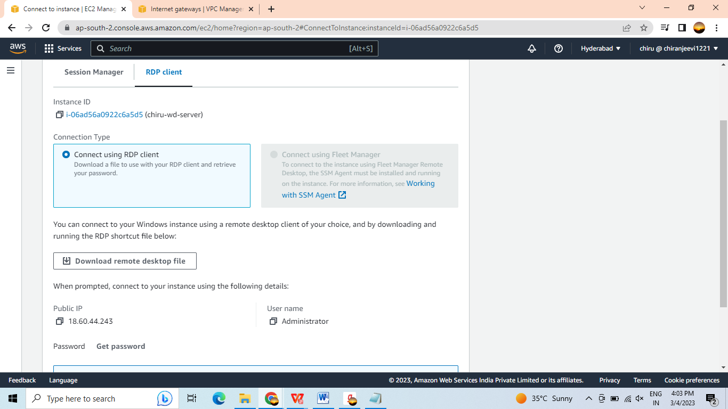

After Downloading.

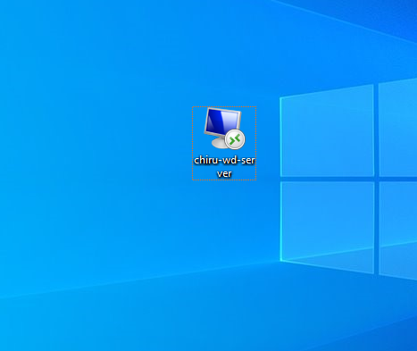

After opening it we can look new window. Like below. This is also called as Virtual Box.

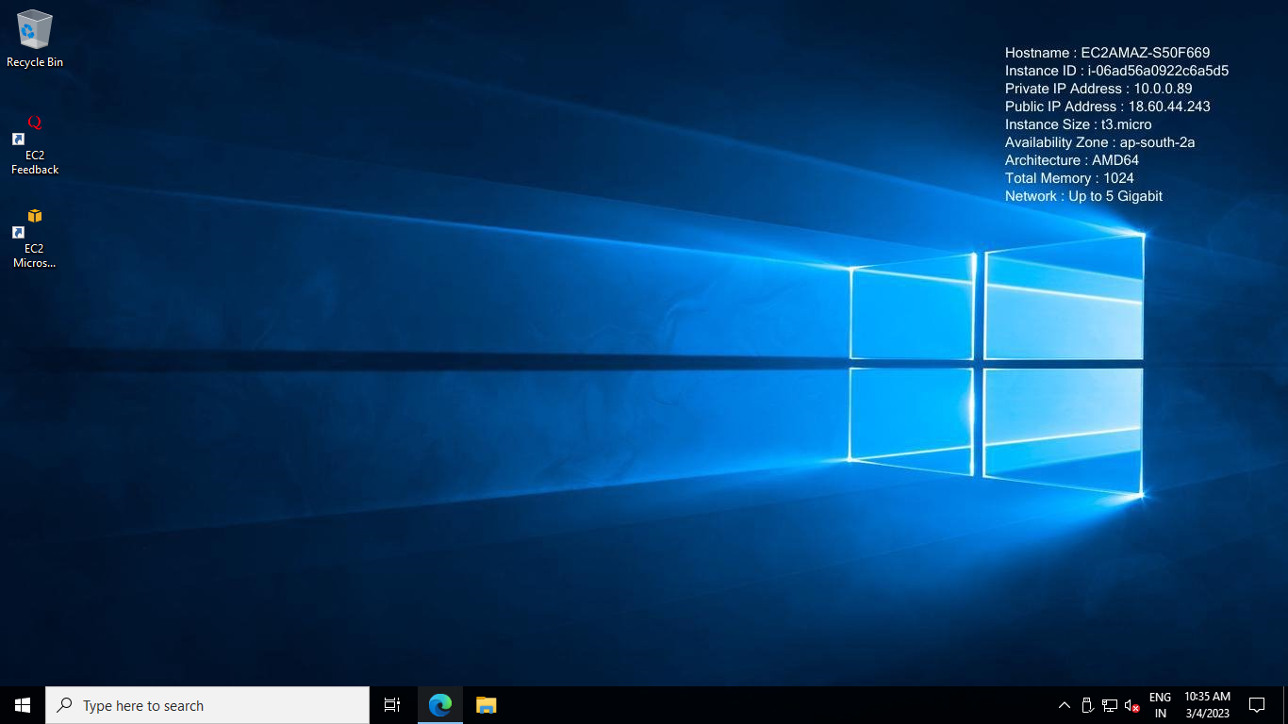

Here we need to run the XAMPP Server to Run the application.

In that Xampp Server we need to run MySQL and Apache to run our Application.

After running we need to import the sql file into the Myphp Admin page. From that we will get the backend.

It helps to run the application .

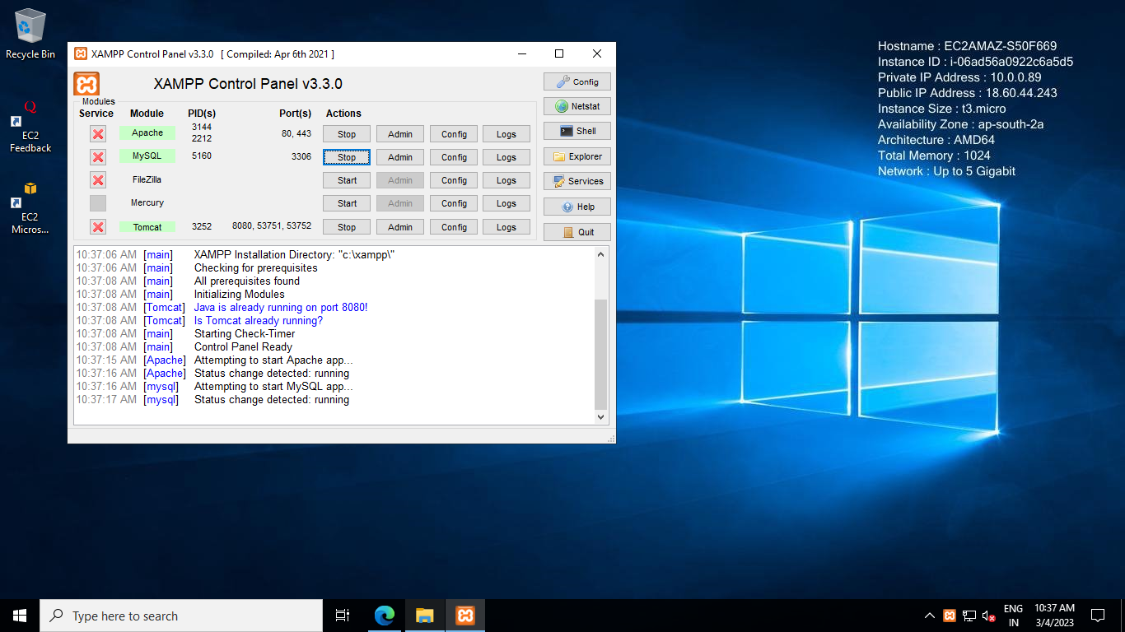

After Starting the two things need to run our application with local host.

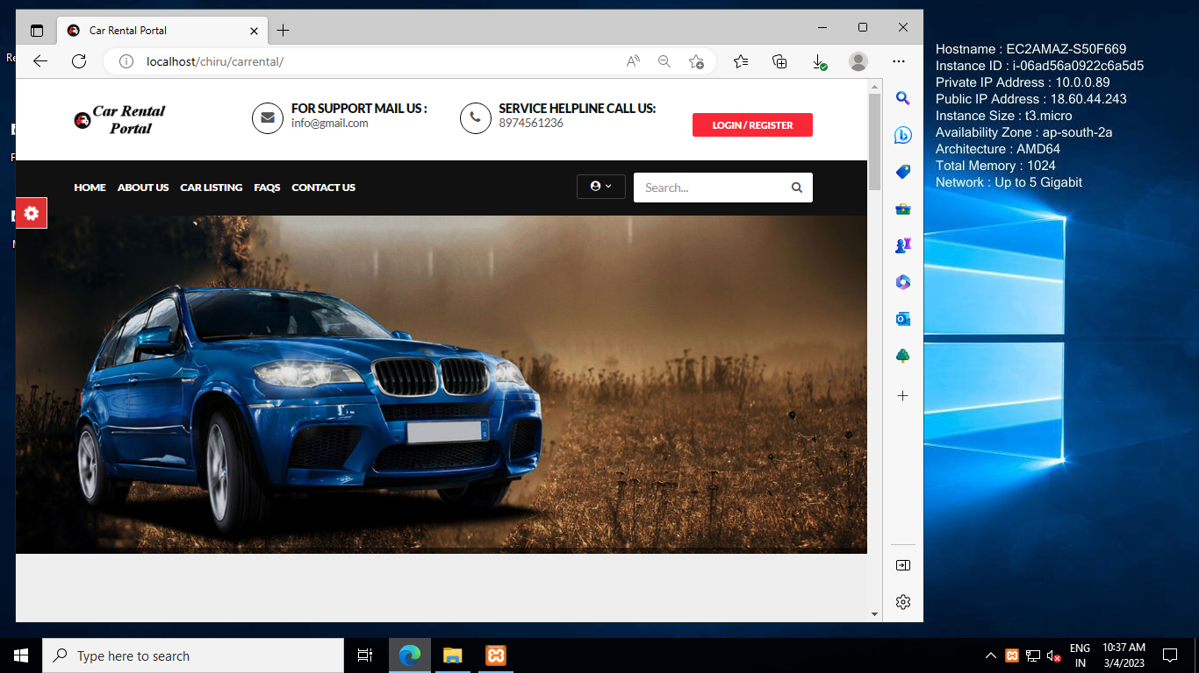

After open with the local host now we need to run the application with the public IP address in side the remote server.

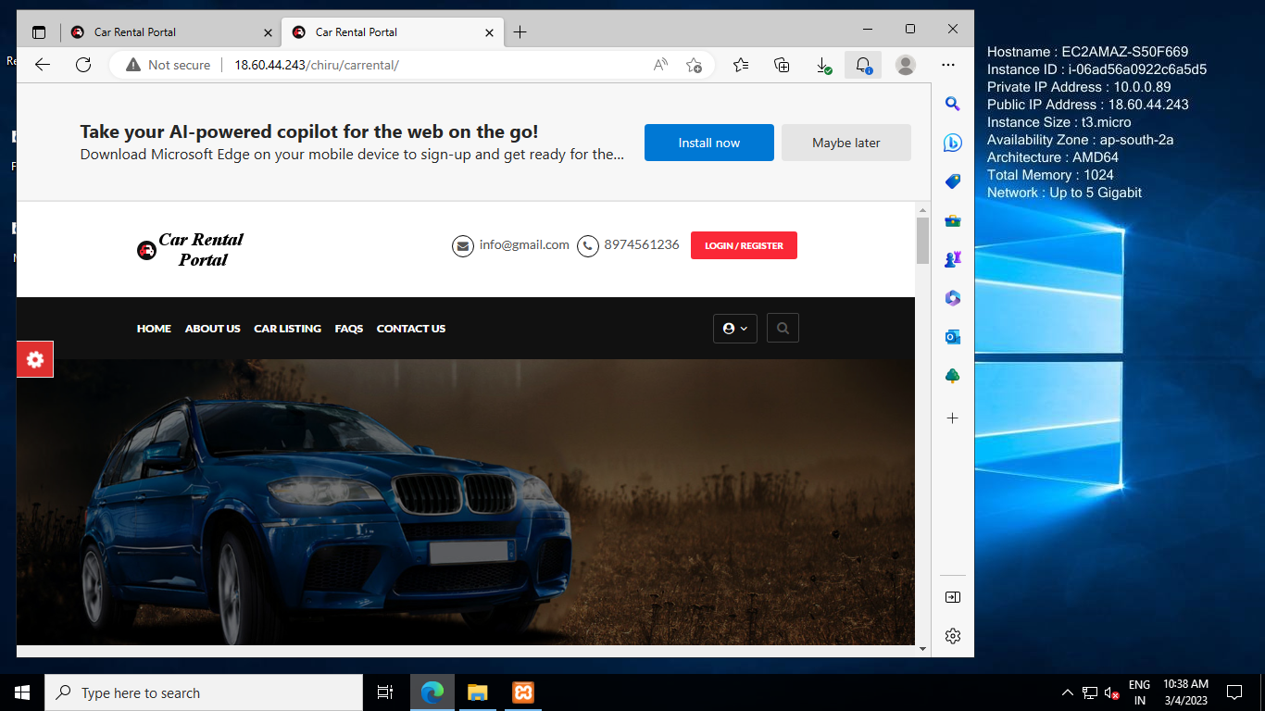

Here in the above picture in search bar there will be an IP address it is public IP address. We can access it from out of the server also.

Any can access the website with the Public IP address in mobiles pcs and anywhere we can access it. While accessing the website we need to put the EC2 in running mode that time we can access from anywhere.

So we need to keep it in running mode only. The ec2 will never end up until we terminate it. If is there any network issue that time we can’t access the webpage.

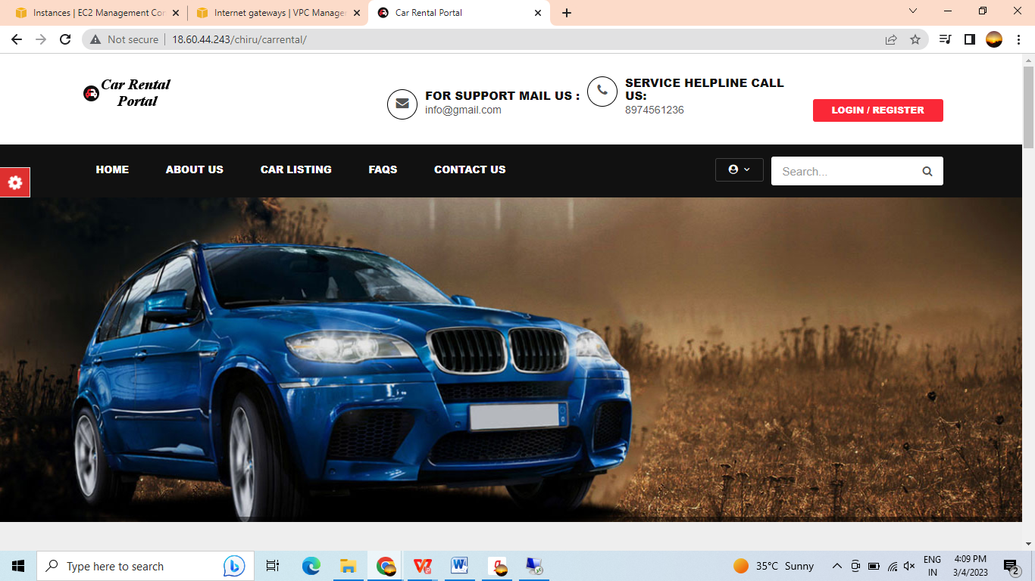

In the above image I had run web site out of the server.

# Implementation and System Testing

After all phase have been perfectly done, the system will be implemented to the server and the system can be used.

### System Testing

The goal of the system testing process was to determine all faults in our project .The program was subjected to a set of test inputs and many explanations were made and based on these explanations it will be decided whether the program behaves as expected or not. Our Project went through two levels of testing

* 1. Unit testing

2 .Integration testing

### Unit Testing

Unit testing is commenced when a unit has been created and effectively reviewed .In order to test a single module we need to provide a complete environment i.e. besides the section we would require The procedures belonging to other units that the unit under test calls Non local data structures that module accesses. A procedure to call the functions of the unit under test with appropriate parameters

##### Test for the Topics Page

**Testing the selected topics -** This page is used give the car to rent.

##### Test for the Result Page

**Testing the Score display –** This page is used to display Cars for rent.

### Integration Testing

In the Integration testing we test various combination of the project module by providing the input.

The primary objective is to test the module interfaces in order to confirm that no errors are occurring when one module invokes the other module.

# Conclusion

In conclusion, hosting a dynamic website using AWS EC2 and VPC provides numerous benefits for businesses. The scalability, security, customization, high availability, and cost-effectiveness of AWS infrastructure make it an ideal solution for hosting dynamic websites. While there may be some technical complexity and potential for cost overruns, the advantages typically outweigh the disadvantages when properly managed and optimized.

Proper planning, management, and optimization are crucial to ensure that the website is secure, performance, and cost-effective. This includes implementing best practices for managing infrastructure, optimizing for cost and performance, and disaster recovery planning. Additionally, businesses must carefully consider their specific needs and resources before deciding to host their website on AWS.

Overall, hosting a dynamic website using AWS EC2 and VPC can help businesses create a robust and scalable web solution that meets their specific needs. With the right tools, expertise, and planning, businesses can take advantage of AWS infrastructure to create a website that is secure, performance, and cost-effective.

# References

##### For HTML

* https://[www.w3schools.com/html/html_intro.asp](http://www.w3schools.com/html/html_intro.asp)
* https://[www.tutorialspoint.com/html/index.html](http://www.tutorialspoint.com/html/index.html)

##### For CSS

* https://[www.w3schools.com/css/css_intro.asp](http://www.w3schools.com/css/css_intro.asp)

##### For Java Script

* https://[www.tutorialspoint.com/javascript/javascript_overview.html](http://www.tutorialspoint.com/javascript/javascript_overview.html)

##### For AWS

* https://aws.amazon.com/

**\*\*\*\*\*\*\*\*\*\*\*\*\*\*\*\*\*\*\*\*\*\*\*\*THANKYOU\*\*\*\*\*\*\*\*\*\*\*\*\*\*\*\*\*\*\*\*\***